Auto scaling task

1. Create one VPC in N. Virginia region
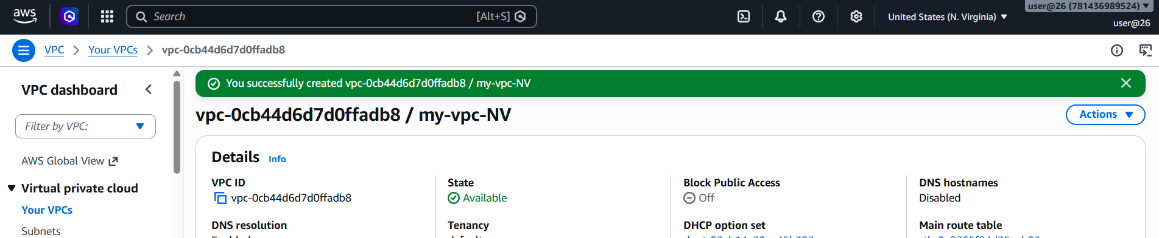
2. Create two subnets: one public subnet and one private subnet
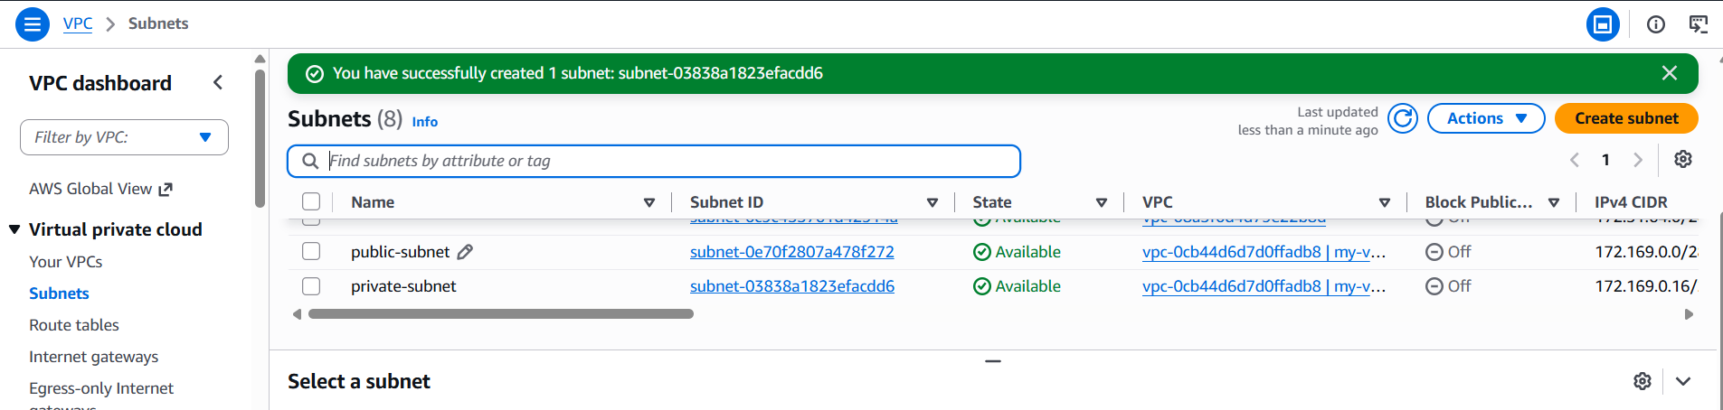
3. Attach an IGW to the VPC
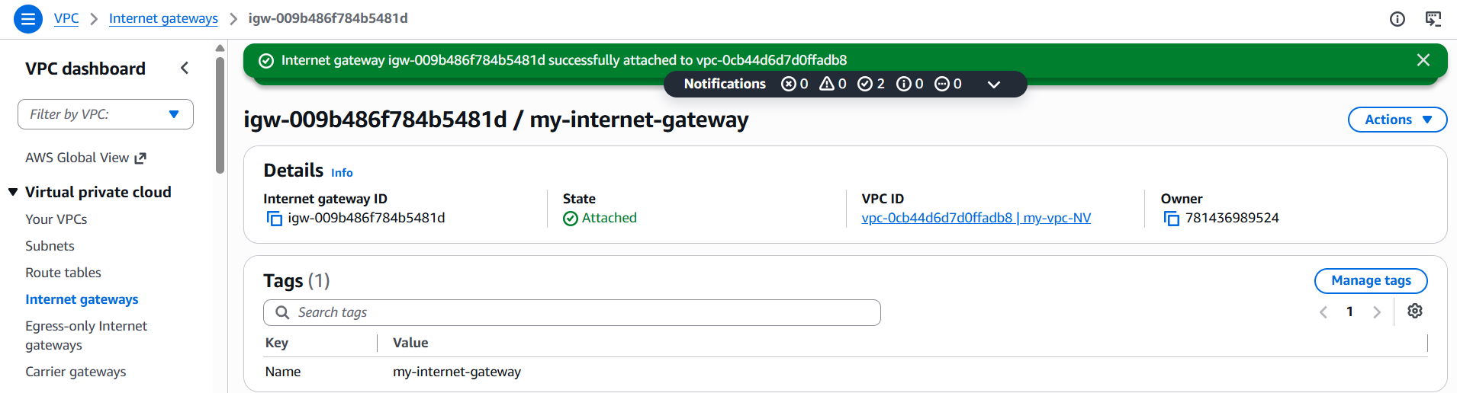
4. Create one public route table (RT) and one private route table
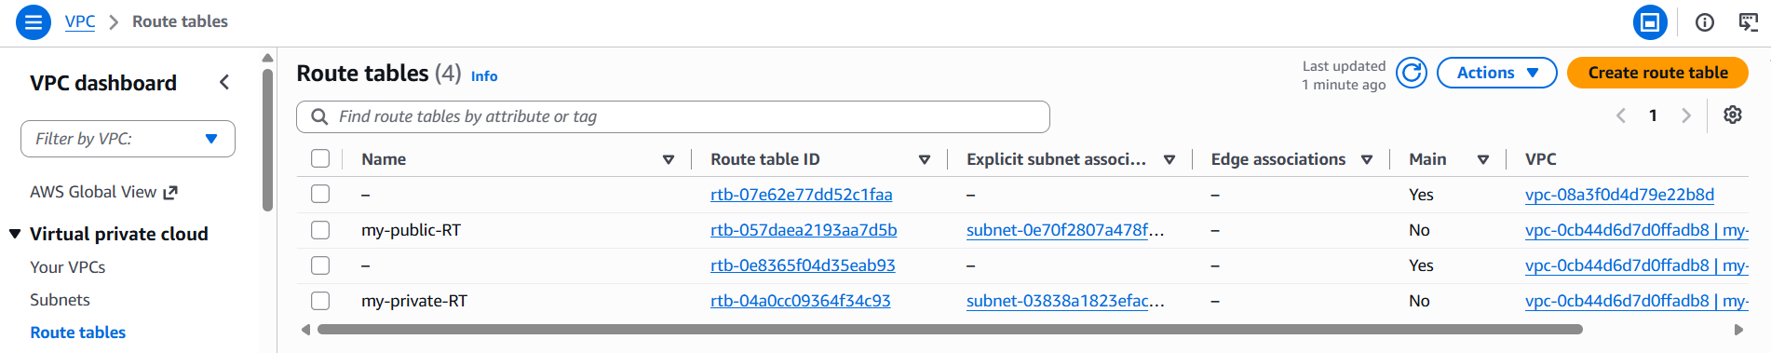
5. Deploy a NAT gateway in the public subnet and attach the NAT gateway to the private subnet
Created one NAT gateway
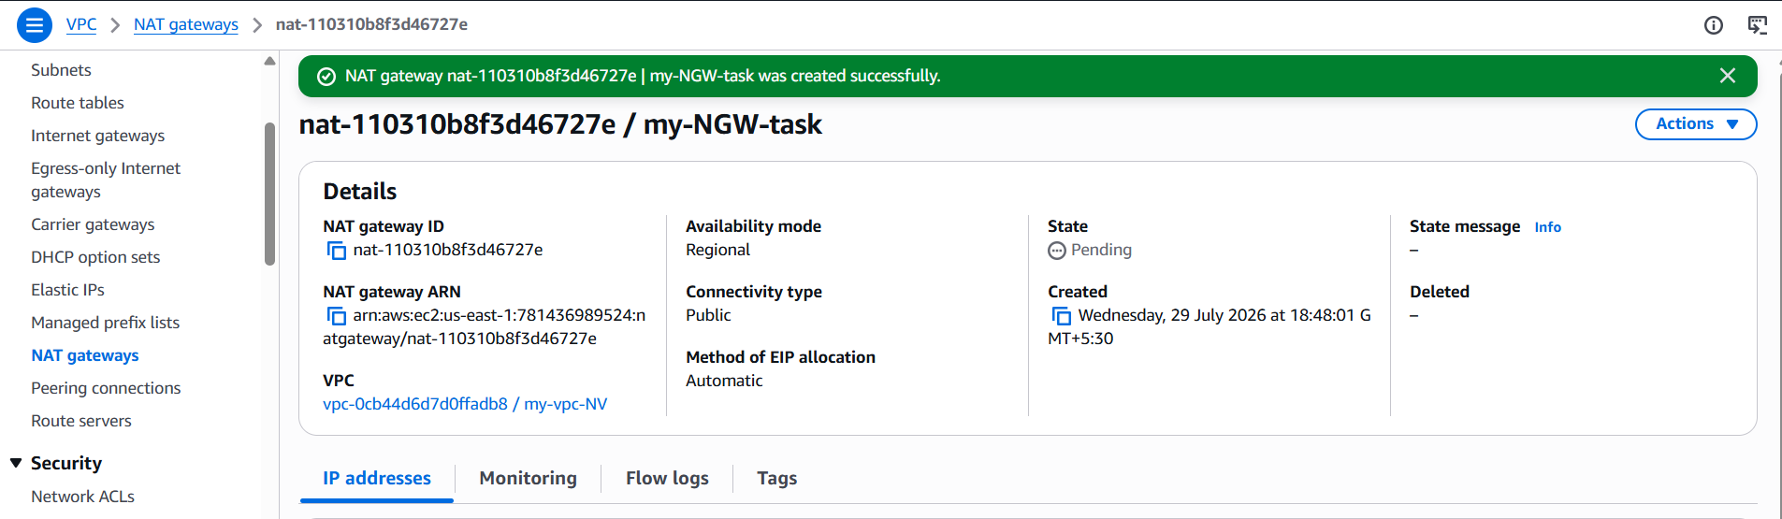
And attached the created NAT gateway in private route table
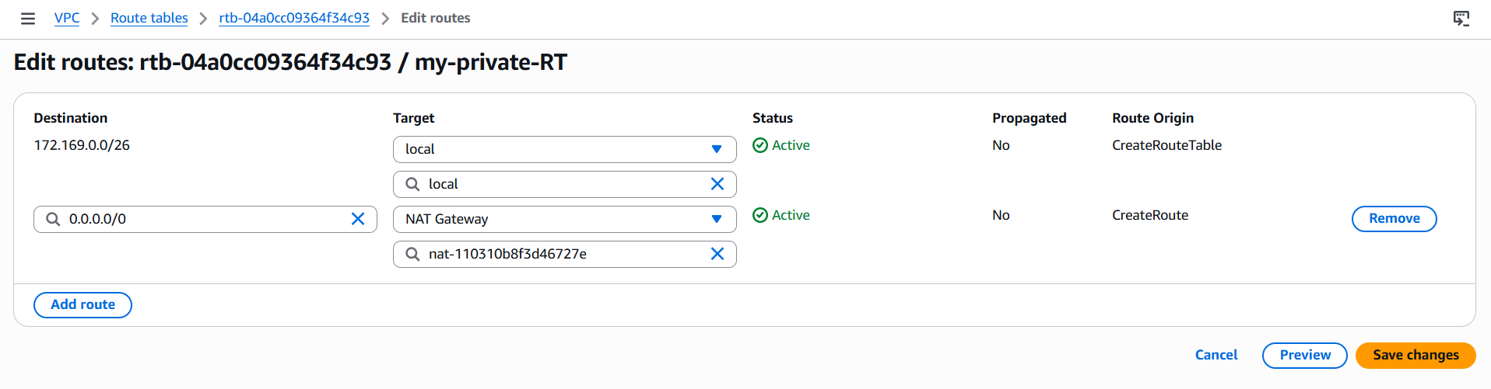
6. Create two instances, one in the public subnet and one in the private subnet
I have created one public subnet using the VPC which I created
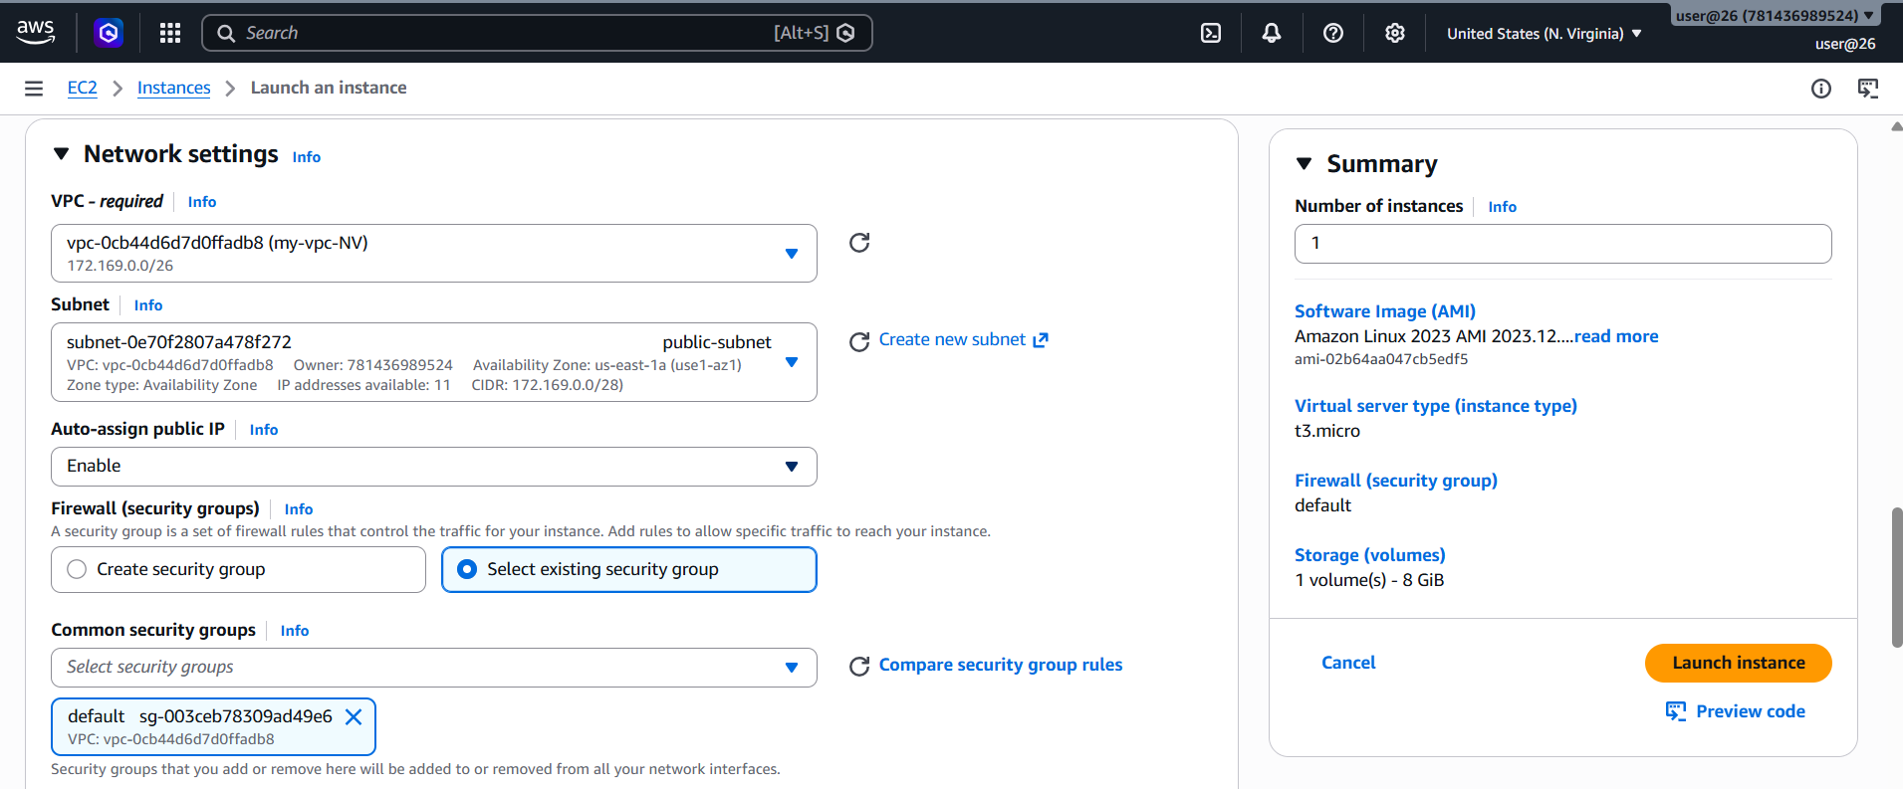
And same with private subnet
So one public and private instance has been created
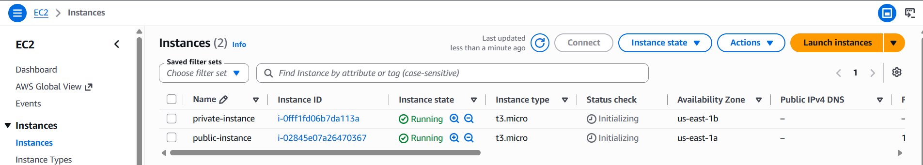
7. Deploy Apache server on both EC2 instances with a sample index.html file
Connect to public instance using ssh and install Apache httpd
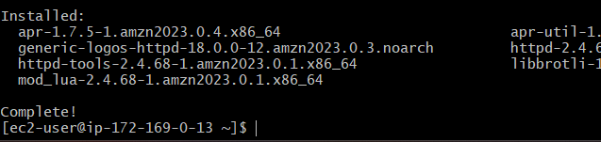
Once it is done, deploy the sample index.html in var/www/html/index.html
And then you can check it with public IP of the instance with the port number
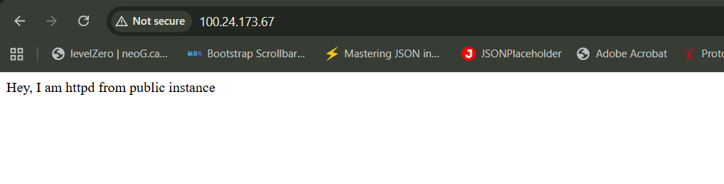
Connect to private instance from public instance(Bastion server)
Ssh -i pemkeyname username@<privateIP>
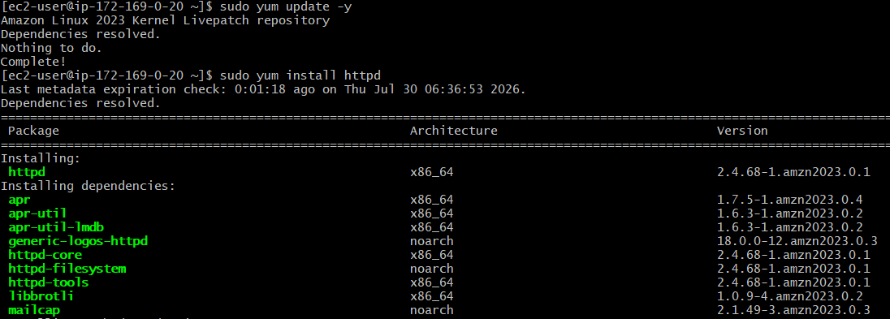
Now If you check it with curl http://<Private IP>:port number you can see the deployed content
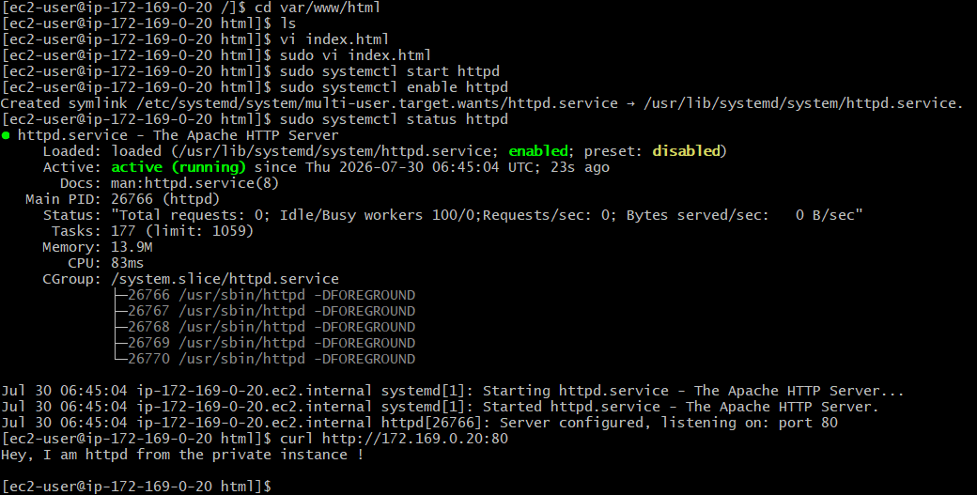

8. Create one application load balancer and attach it to both EC2 instances
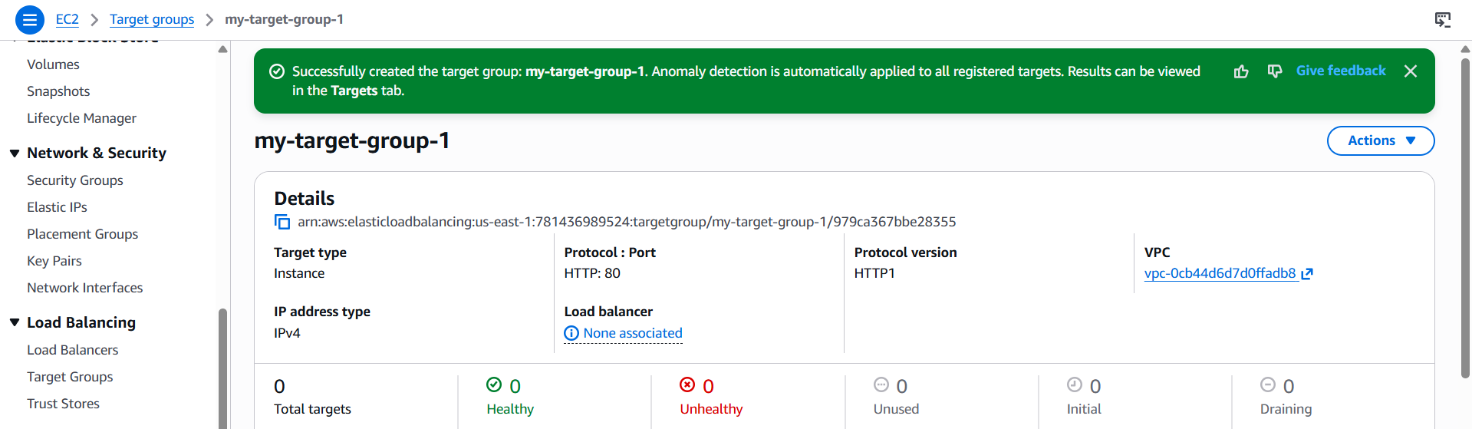
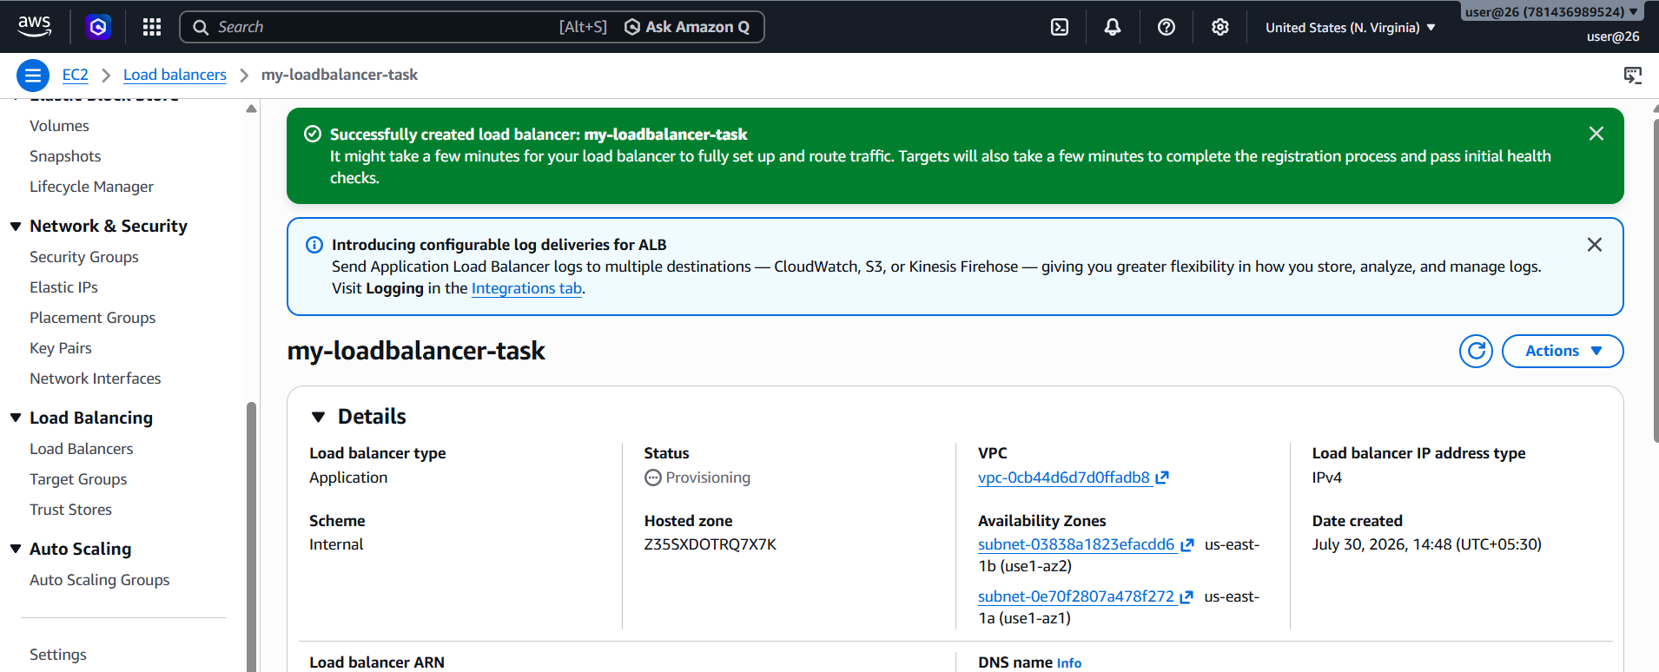
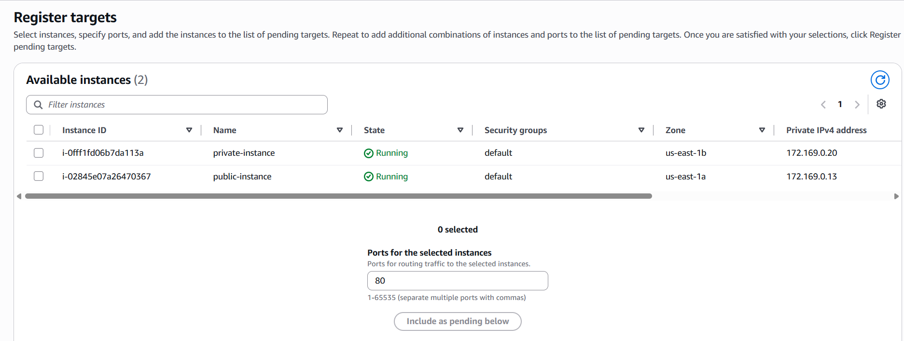
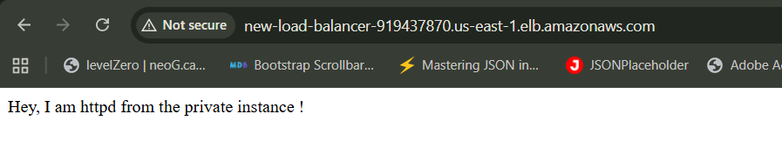
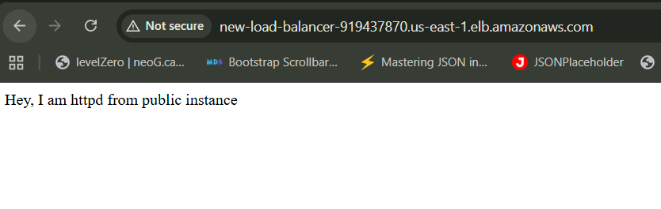
9. Store application load balancer logs in S3
Create a bucket in the same region where you created your load balancer
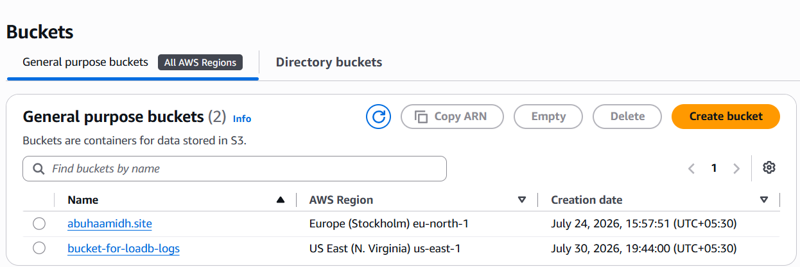
Create a bucket policy to allow the access
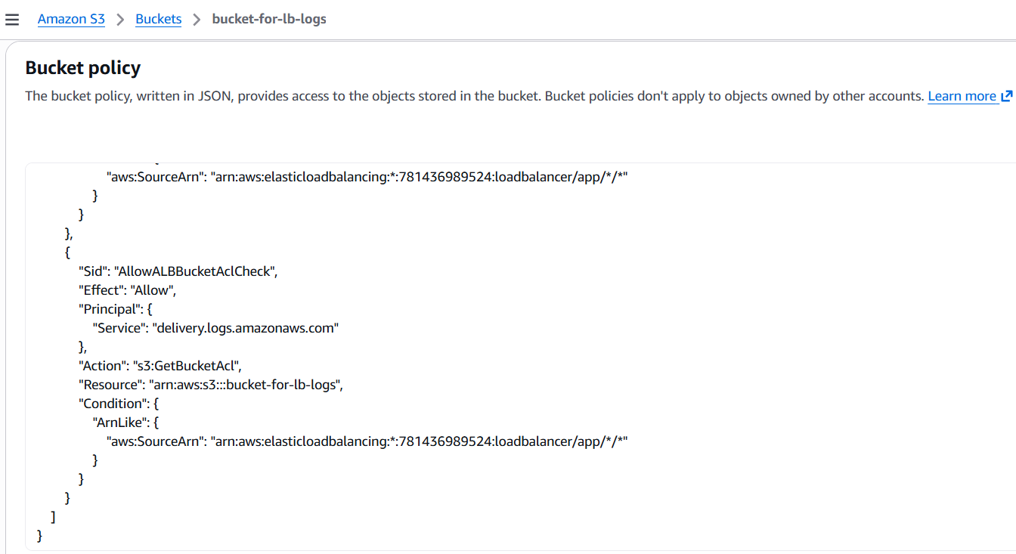
Now go to load balancer, in the attributes section scroll for logging
And then click on access logs and attach the bucket path
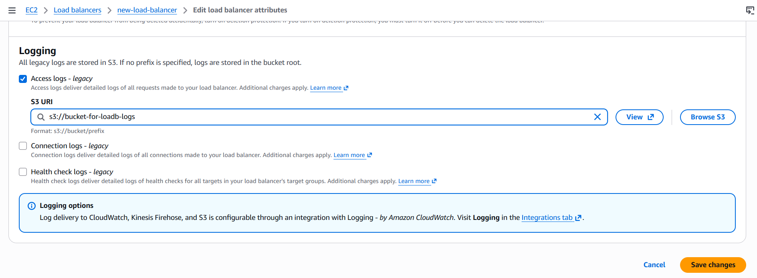
And if you check on the bucket object there will be the logs for the load balancer as shown below
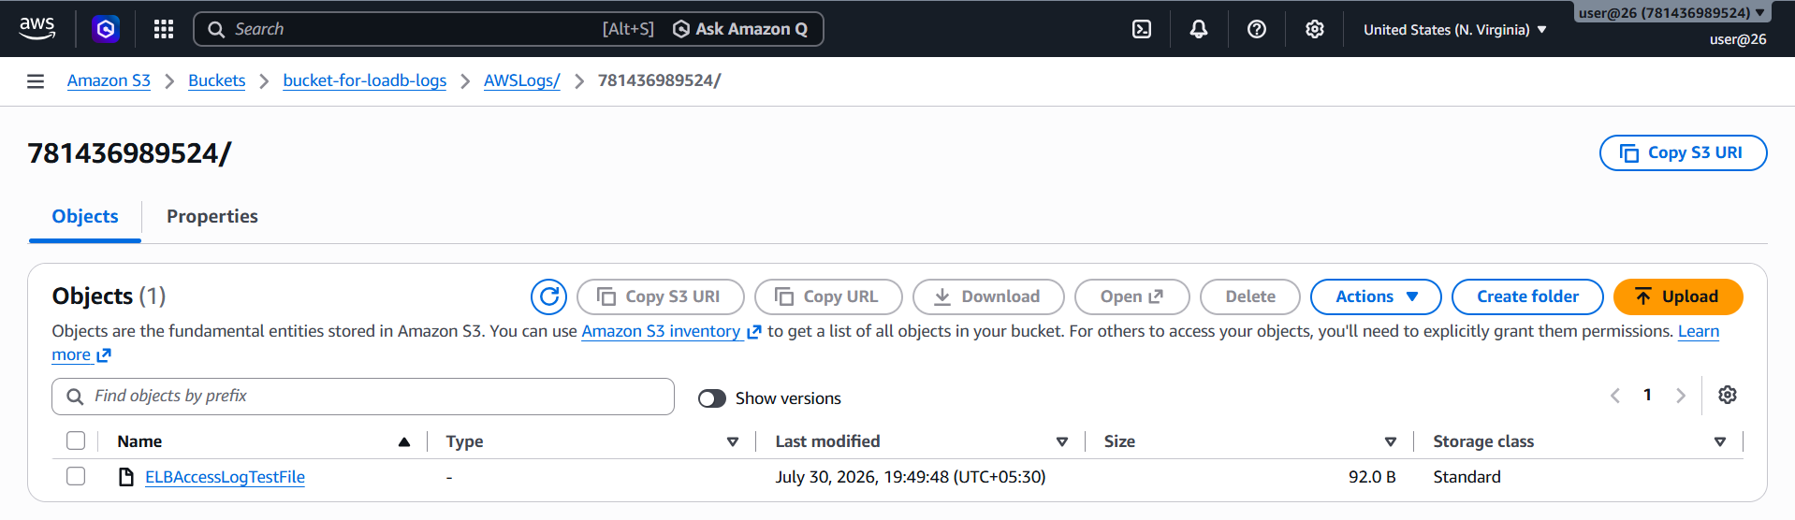

10. Store the VPC flow logs in a CloudWatch log group
Create an IAM Role so VPC Flow Logs can write to CloudWatch
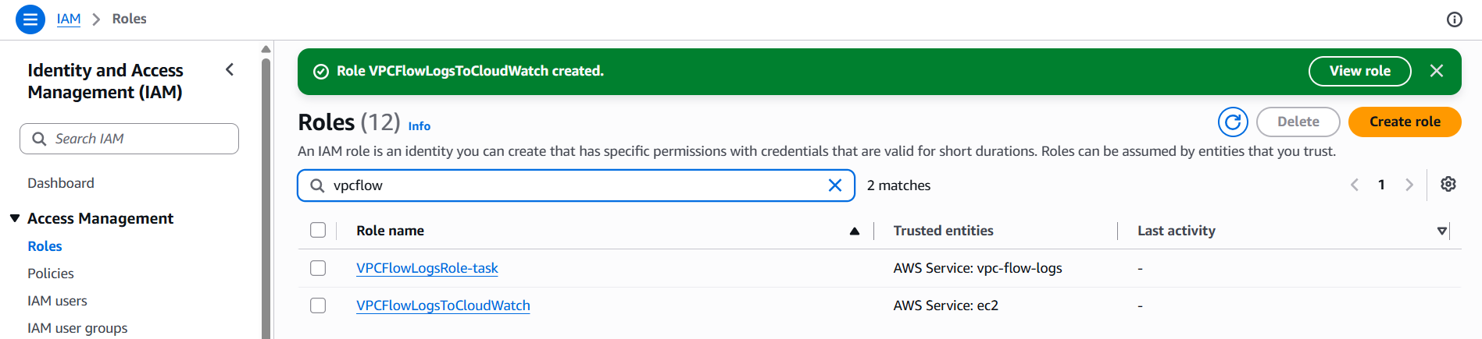
Then open cloud watch console and create a log group
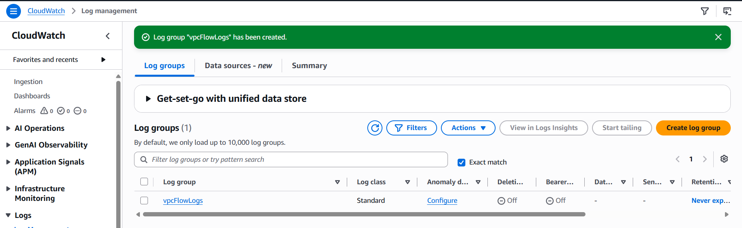
And then in VPC create flow logs, select destincation and then the role name
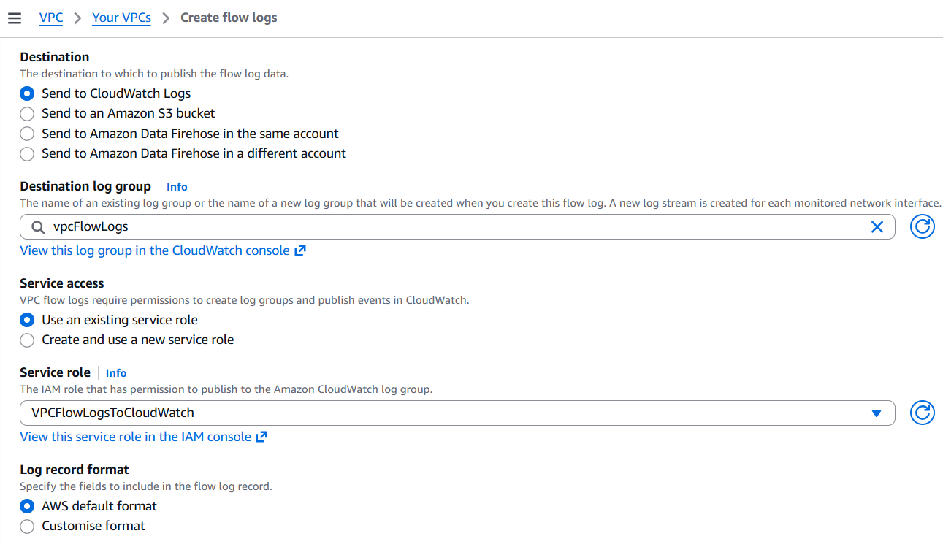
Once after it gets created, you can see the logs in the VPC’s flow logs section
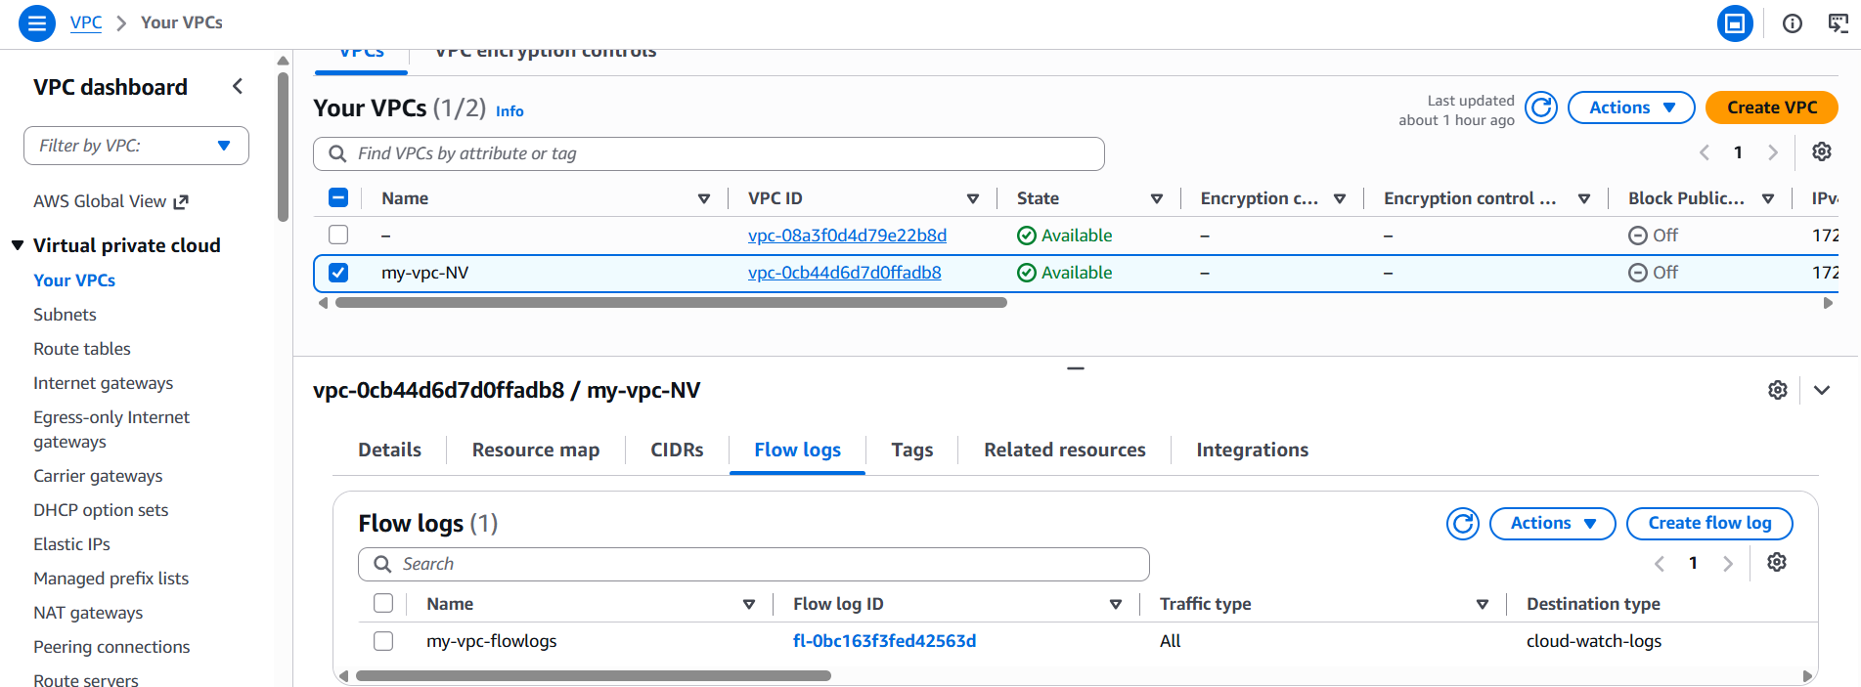
Create a log group in the cloud watch and verify it once
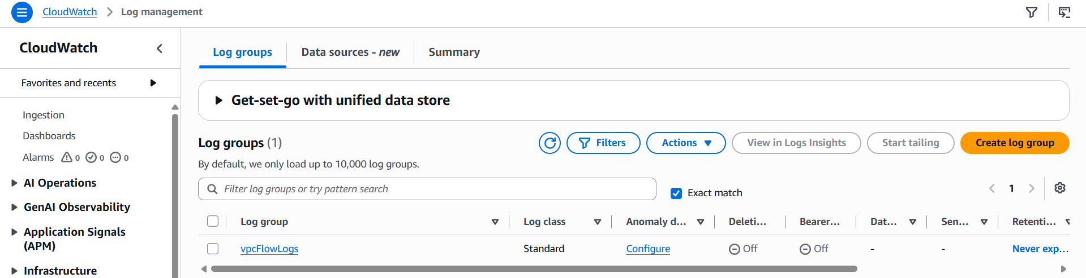

11. Create monitoring dashboards to monitor CPU utilization and to monitor the Apache service
To send the logs from instance to cloudwatch, we need to create an IAM role and the policy for that
Select the instance >> Action >> security >> Modify IAM role
Either you can create a new one or add the existing one
And then you need to create a bash script file and make sure it has the same region as your instance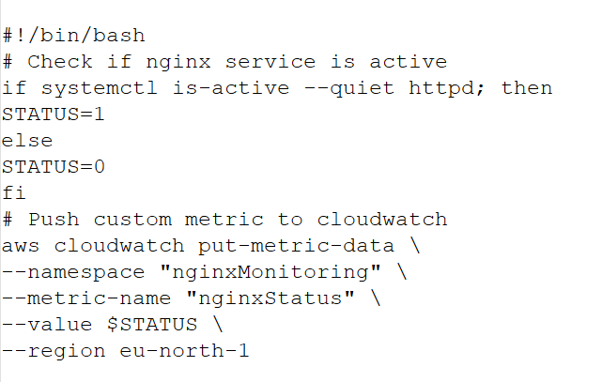
Run the script file
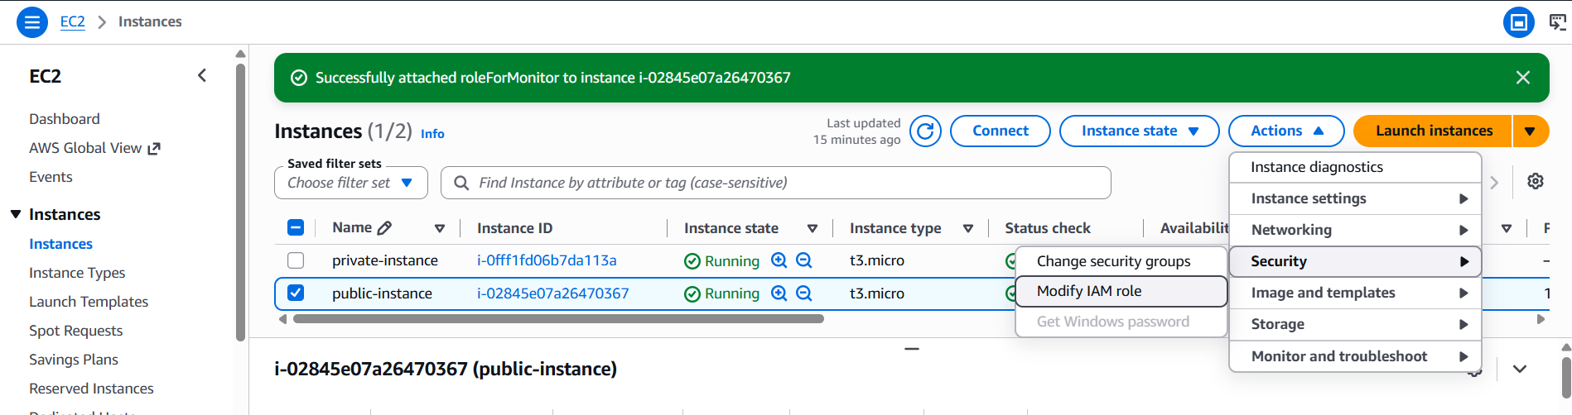
Go to cloud watch and create a dashboard for the status as shown below
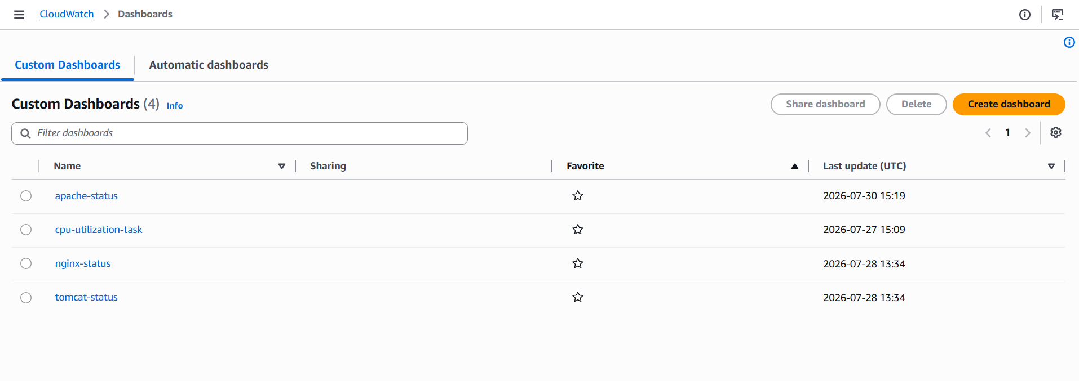
Now, you can see the status mentioned as 1, meaning its working
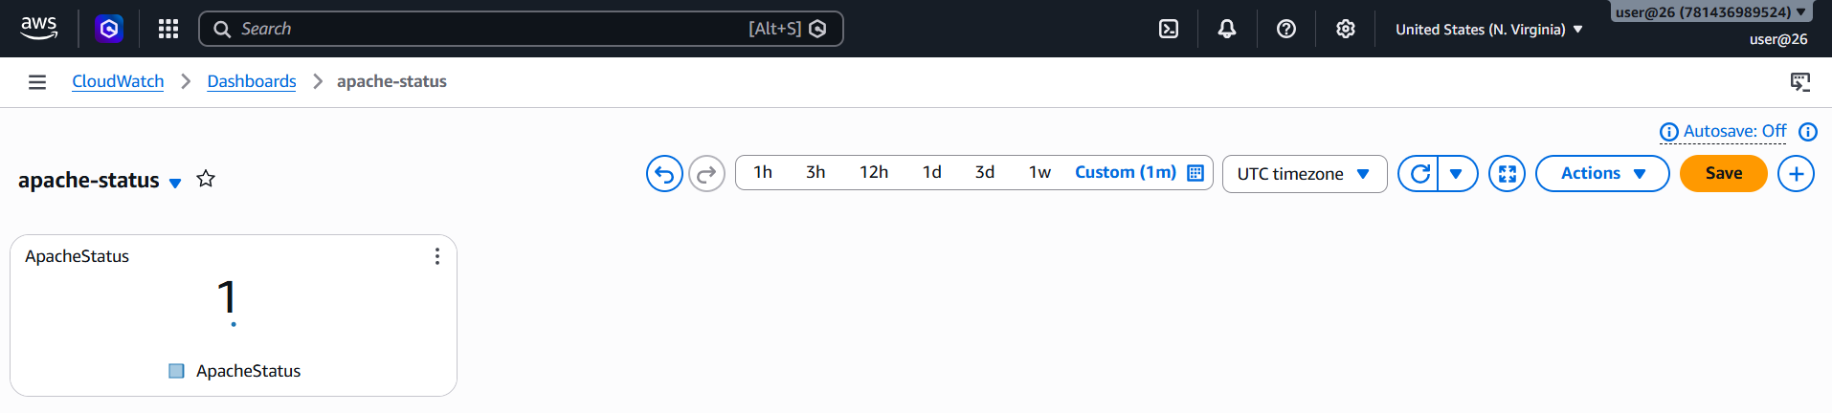

12. If CPU utilization is more than 70%, then it should trigger auto scaling and launch new instance
Create an image in instance >> Action >> create image
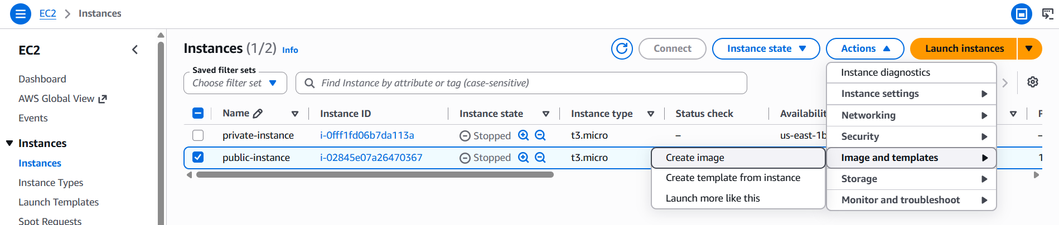
Then create a template as well
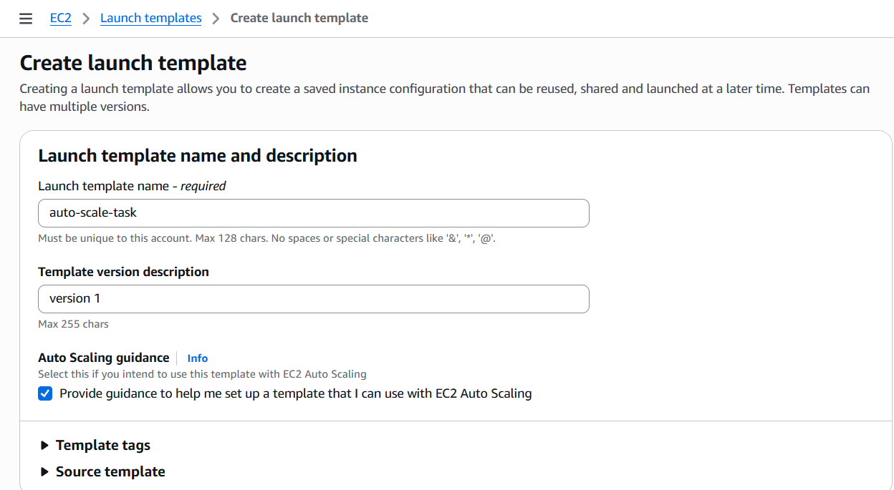
Verify whether it gets created or not
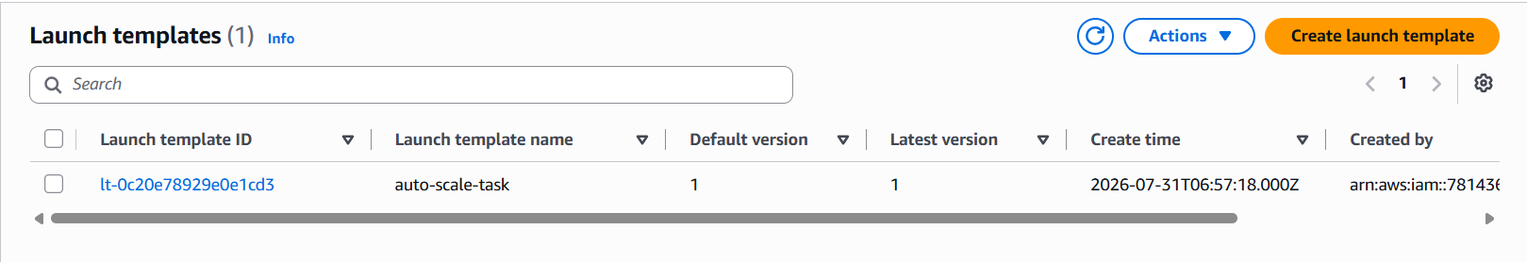
Go to auto scaling groups and create auto scaling groups and give the name and select subnets, and give the security groups
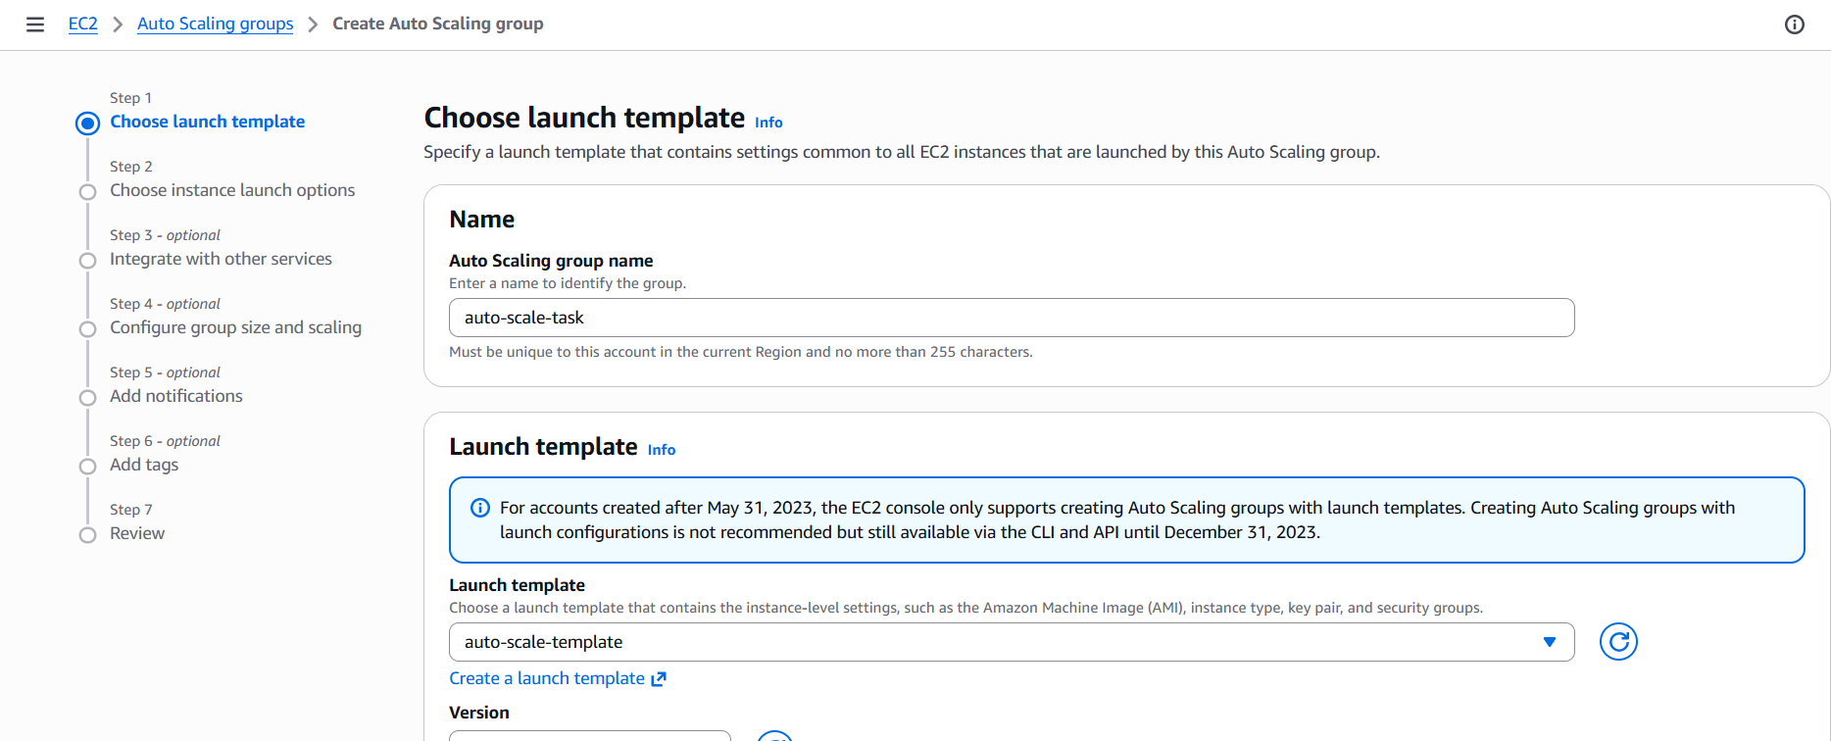
Select the VPC which you already created
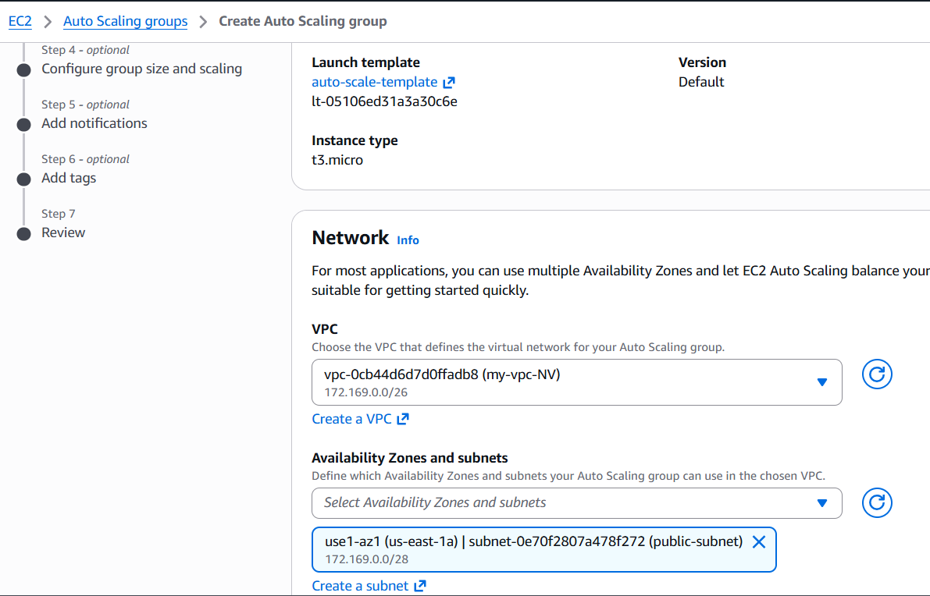
And attach the load balancer as well
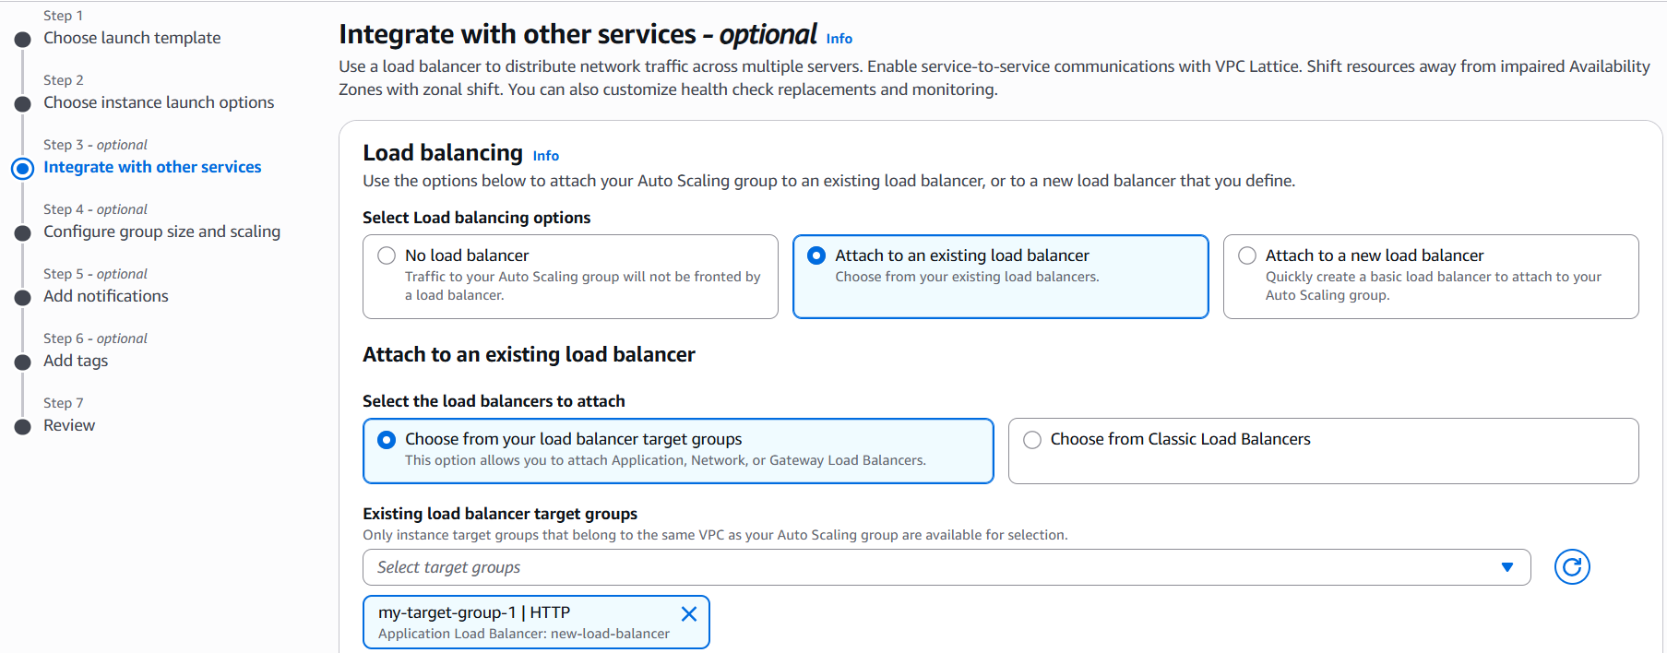
And you can see the auto scale has been created
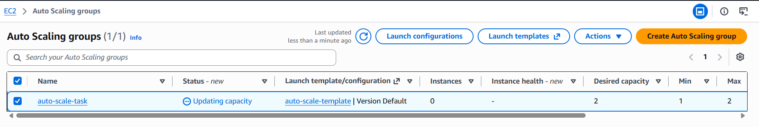
And you can see the instance has been created for the threshold
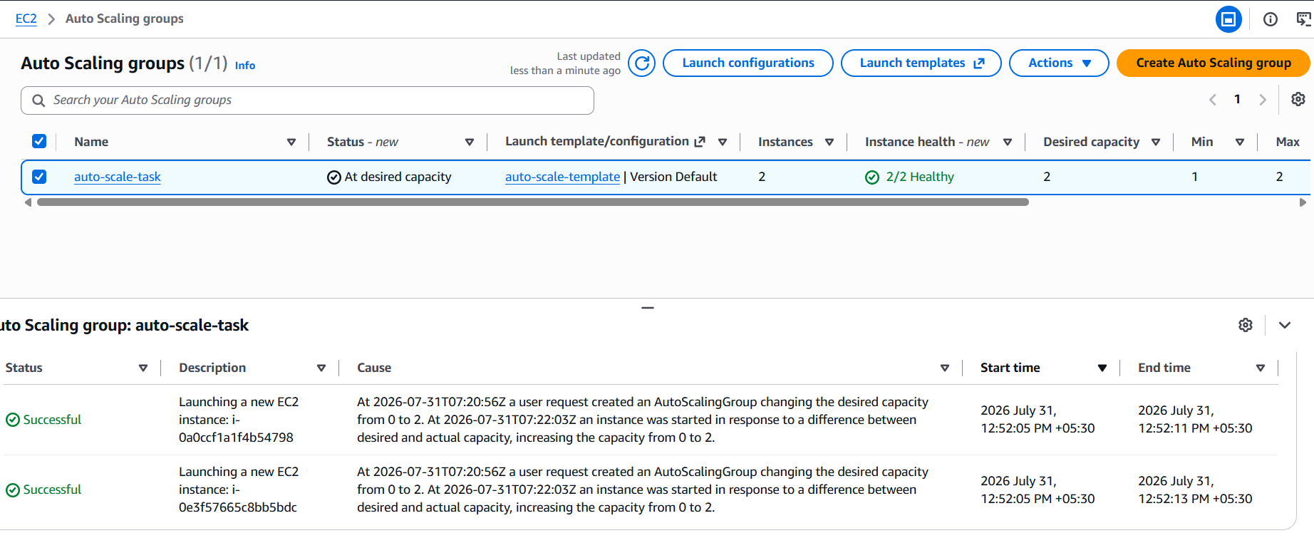
I have checked it in target group as well, its created
